Michigan Service Scholars Program

2011-12 Member Application Form
Student Name:
College/University:
Are you currently enrolled as a student at this college/university? Yes No
Supervisor: ____________________________________________________________
Current Address:
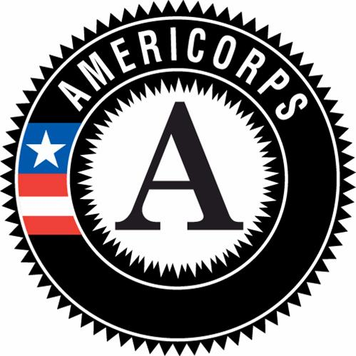

Phone:
Email:

Which MSS service category will you participate in (please confirm with yourhost campus supervisor):
- Teacher Preparation
- College Positive Volunteers
- Community/Faith-based Service

How do you envision completing the 300 hours of service?

You must bring the following items to the training. Copies are allowed. If you cannot, please see your campus supervisor.
            - Proof of Citizenship (Birth Certificate, Passport, etc.)
            - State-Issued Photo ID (Driver License, State ID Card, etc. – STUDENT ID CARDS ARE NOT ACCEPTABLE!)

You are required to attend one member training. You must be present for the entire training. No exceptions can be made. By submitting this application, you are committing to attendance at the selected training.

Class I– Official Service Start Date: February 1, 2012

Date of Training: Location: Time: RSVP Deadline:
- Tuesday, February 21 Detroit 5:00-9:00pm ASAP

